Introduction to Matter Study Guide
- What is the difference between mass and weight? What is the unit of measurement for mass? How is the mass of an object found?
Mass is the amount of matter in an object. Mass is measured in grams or kilograms. We find mass with a triple beam balance.
Weight is a measure of the force of gravity on an object. It can change depending on location in the universe.

- Which of the following units would be used to express the volume of a solid, such as a marble?
a. Liters (l) c. Cubic centimeters (cm³)
b. Millimeters (mm) d. Newtons (N)
- You poured 3 liquids into a beaker. Explain how could you tell which one is the densest?
The most dense liquid will sink, the least dense liquid will float.

- What is the equation for finding density? What are the (metric) units? Be able to solve density equations.
Density= Mass/Volume units for density g/cm³ or g/ml
Remember the broken heart equation!

- What is Matter?
Anything that has mass and takes up space.

- What is density? Note the density of water 1gm/cm3 and be able to compare it to whether objects/liquids will sink/float/or suspend (same as density) water.
Density is a measure of the amount of mass in a given volume.
More dense liquids sink, less dense liquids float. Same density is suspended in the liquid.
- Define physical property. Give 2 examples.
A characteristic of a pure substance that can be observed without changing it into another substance. Examples: density, mass, volume, boiling point, freezing point, melting point

- Define a chemical property. Give 2 examples.
Characteristic that cannot be observed without altering the substance. Examples: Flammability and reactivity

- Define a physical change. Give 2 examples.
A change in matter that does not produce new substances. Examples: cutting, folding, phase changes.

- Define a chemical change. Give 2 examples.
A change in matter that produces one or more new substances. Examples: burning, cooking, rusting

- Mass and volume are used to find what property of matter?
- Density c. Reactivity
- Ductility d. Weight
- Boiling water is an example of a:
a. Physical property c. Chemical property
b. Physical change d. Chemical change

- Define Solubility, Solute and Solvent:

Solubility: The ability to dissolve in another substance
Solute: The substance that is dissolved (usually a solid in smaller amounts).
Solvent: The substance dissolving the solute (usually the liquid in larger amounts).

- List the steps to find the volume of an object using a graduated cylinder and the displacement method.
Fill a beaker or graduated cylinder with enough water to completely immerse the object.
Record the baseline initial water level.
Drop the object in.
Record final water level.
The difference in the water levels (Final level- initial level) is the volume of the object (the amount of space displaced by the object).

- Does the sample size matter when finding the density of a pure substance?

NO! It is independent of the amount of matter present.

Atoms, Elements and Compounds
- Define atom, element and compound. Give an example of each. Draw a picture of each.

Atom: Basic unit of matter. Made of protons, neutrons, electrons.
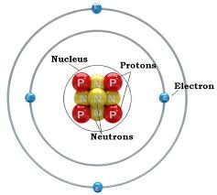
Elements: A pure substance made of only one kind of atom

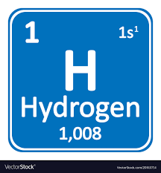
Compound:
A substance made up of atoms of two or more different elements joined by chemical bonds
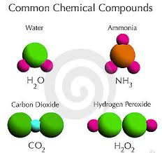

- All Atoms have ___mass____________________ and _____take up space_________________________.
- What is the main difference between the atoms of two different elements on the periodic table?

The number of protons, thus the atomic mass.

- Explain the difference between matter and energy.

Matter- has mass and takes up space
Energy- does not have mass or take up space. Energy is the ability to do work. Energy moves matter. Examples: Heat, electricity, sound

States of Matter
- Solids: Explain the energy and motion of the molecules. Understand why shape and volume do not change for solids. Draw the particle arrangement.

Lowest energy state. Atoms/molecules vibrate in place.

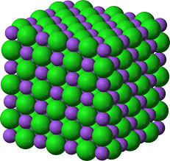

- Liquids: Explain energy and motion of the molecules. Understand why shape of a liquid changes, but volumes of liquids do not change. Draw the particle arrangement.

Medium energy and motion. Particles flow past each other. More space between particles.
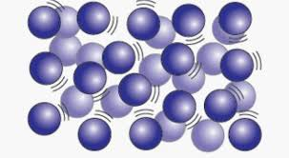

- Explain and motion of the molecules. Why do shape and volume can always change for gases? Draw the particle arrangement.
High energy and motion. Lots of space between particles.
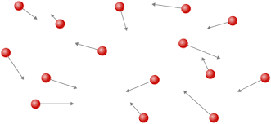

- Solve: What is the density of an object has a mass of 500 grams and a volume of 250 cm³? (use the correct units and show your work)

Density=Mass/volume
Density= 500 g/250 cm³
Density= 2g/cm³
- What is the smallest building block of matter?
The smallest building block of matter is the atom.

