Name ______________________________________________ Date________________________
Guided Notes
Introduction to Matter

What is Matter?
- Anything that has mass takes up space.
- Everything you see: _________________, __________________, ___________________
- Some things you cannot see like _____________________
Matter and Volume:
What is Volume?
- The _________________ _____________________up by an object.

- Two objects cannot share the _______________________ _____________________

- Ex: _______________ and _________________in the quick lab
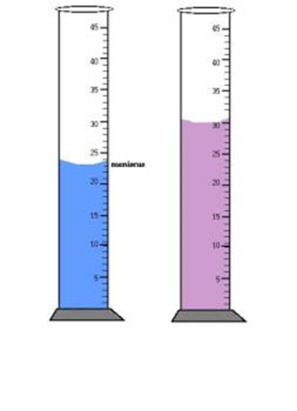
What materials are used to measure volume?
- __________________ ___________________and beakers.

- Liquid in these have a ______________ ____________ water line.

- Read the bottom of the _______________ for accuracy

Define and Draw the meaning of: Meniscus
Define: _____________________________________________________________________________
Draw:

What unit is used to measure liquid volume?

How is the Volume of a Regularly Shaped object found?
- Multiply the ___________ _____________________of the object

- volume = length x width x height or v = l x w x h

- units used will be _____________________ _____________(_____) or cubic centimeters (_______)
How is the volume of an Irregularly shaped object found?
- Water displacement method _______________an object in a ______________ _____________ of
water (30 ml) the water level will rise (40 ml) The difference between the ______
___________represents the volume of the object: _______________________________________
- 1 ml = 1 cm3 both can represent volume
- Almost always _________________________in ml and solids in ____________
Weight vs. Mass
What is the difference between mass and weight?
- Mass will stay the same for an object at ___________________ ________________

- Mass measures an objects amount of __________________

- Measured in grams (g) or kilograms (kg)

- Weight changes due to ______________________ ___________________ and distance of celestial body Planets, stars, etc.
- Weight measured in ___________________and ______________________

Review Objectives
Answer the following questions:
Describe the three properties of all matter.
___________________________________________________________________________________
___________________________________________________________________________________
Identify the units used to measure volume and mass.
___________________________________________________________________________________
___________________________________________________________________________________
Distinguish between mass and weight.
___________________________________________________________________________________
___________________________________________________________________________________

